The Sangala Initiative:
Establishing a K–12 Engineering Program for East Africa
Glen Bull, John Wanda, Kelly Dooley, and David Slykhuis
University of Virginia · REACH for Uganda · International Technology and
Engineering Educators Association · National Technology Leadership Society

Abstract
Lasting educational change in under-resourced regions is rarely produced by the donation of equipment alone. The Sangala Initiative, a project initiated by the National Technology Leadership Society (NTLS), addresses knowledge bottlenecks in the Global South by building local engineering capacity to better both education and the community, starting with establishing a K–12 engineering program suited to the needs and conditions of East Africa. Students in the program will design and fabricate scientific tools that meet genuine community needs – beginning with a 3D-printed microscope and a locally fabricated weather station – and acquire the expertise to maintain and extend those tools after high school. Anchored by a pilot at Hawthorne-Scribner High School in Uganda’s Mt. Elgon region, the initiative is guided by the principles of authentic purpose and reciprocal innovation. This article documents the program’s goal, structure, and early work, and considers how member associations can collaborate to extend the model.
Key Words: engineering education, digital fabrication, open-source hardware, reciprocal innovation, east Africa, Global South

Introduction
Affordable digital fabrication has changed what is possible in schools, but access to tools does not ensure the capacity to use, sustain, and improve them. In many regions of the Global South, the deeper constraint is not the absence of a particular device but the absence of local expertise to adapt technology to local conditions and to keep it working over time. The Sangala Initiative begins from this premise. Rather than treating technology as something to be delivered, it treats engineering education as the means by which a community develops the capacity to solve its own problems. The word “sangala” means joy in the Lugisu language spoken in the Mt. Elgon region in East Africa. The initiative aspires for students to find joy in learning through innovations that improve their communities. Because joy broadens thinking and encourages curiosity, it can become a catalyst for the creative insight that drives innovation.
The Sangala Initiative was initiated by the National Technology Leadership Society, a coalition of national teacher-educator associations established in 1999 to advance the effective use of technology in education. The overarching goal of this initiative is to address knowledge bottlenecks in the Global South. Its immediate objective is the establishment of a K–12 engineering program appropriate to the needs and conditions of East Africa – a program that builds capacity for the larger goal while meeting the immediate needs of the local community. The thesis of the work is straightforward: a local engineering program suited to the region is required to bring about lasting change. The aim is to prepare local student engineers who, as part of their coursework, develop solutions that meet community needs, and who, after graduation, form a pool of candidates qualified to maintain and expand on the tools and systems they helped create.
This article documents the goal, structure, and early work of the Sangala Initiative and considers how the associations affiliated with NTLS might collaborate to advance it. It is written as a record of the work for the field, and also serves an immediate purpose: providing shared context for participants in the 2026 NTLS strand, which will convene at the headquarters of the National Education Association in Washington, D.C. in September 2026. The discussion that follows is intended to remain useful well beyond that meeting.

Background: The Consortium and Its Foundation
The Sangala Initiative builds on a foundation established over the past quarter-century by REACH for Uganda (“REACH”), a 501(c)(3) non-profit registered in Arlington, Virginia. REACH established the Arlington Academy of Hope (AAH), a non-governmental organization registered with the Ugandan government to help transform rural communities via education, health care, and community development. To date, REACH and AAH have established two medical clinics, two primary schools, and a high school in the Mt. Elgon region of East Africa that, combined, employ more than 120 clinicians and teachers. The initiative is anchored by a pilot at one of these schools, Hawthorne-Scribner High School, with the goal of eventually extending the program to the middle school and technical college levels.
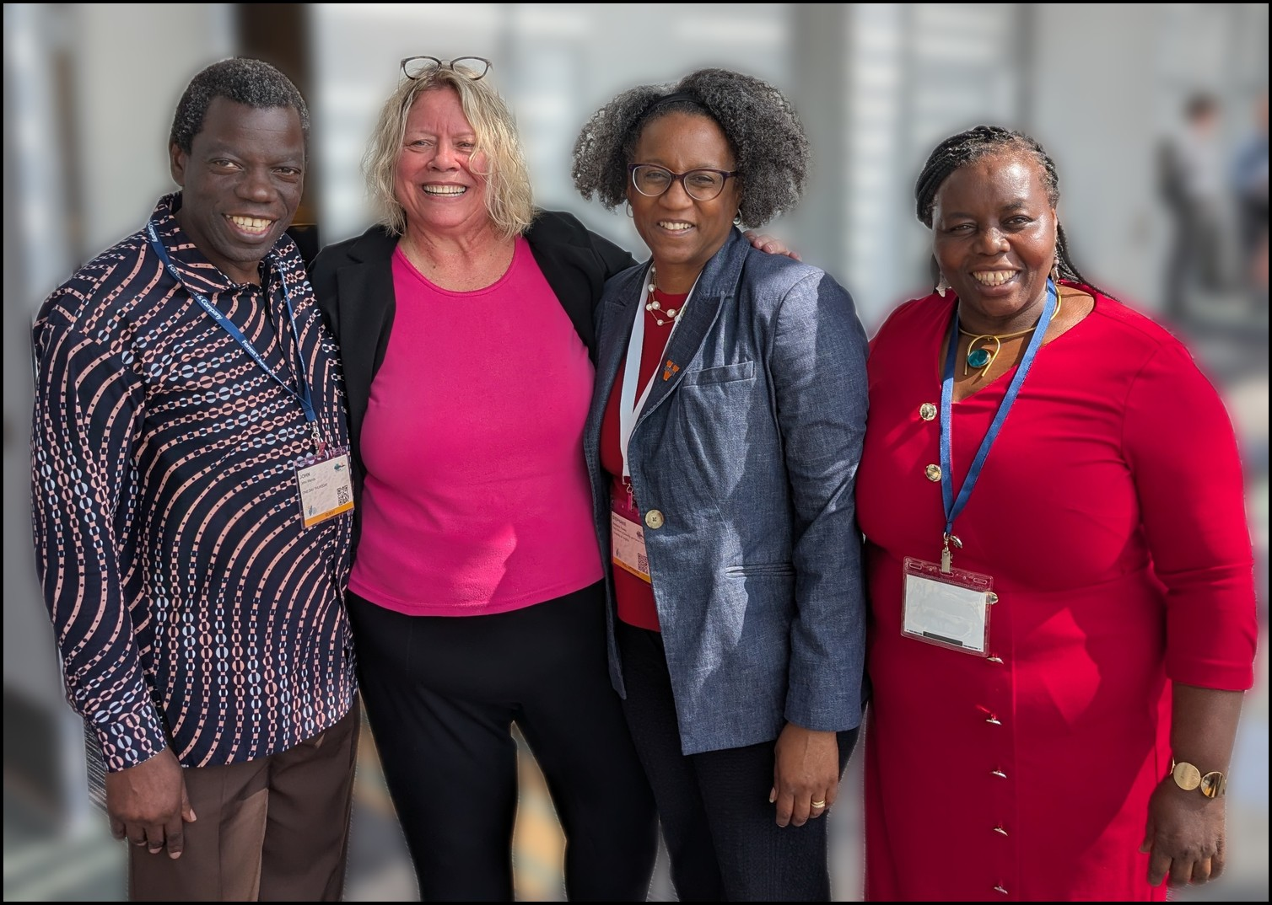
Figure 1. The Sangala Initiative was launched at the 2026 ITEEA Annual Conference. Left to right:
John Wanda, Debra Shapiro (Conference Chair), Stephanie Rowley, and Joyce Wanda.
The work draws on collaboration among international education organizations that are members of NTLS. The associations participating in the project include the International Technology and Engineering Educators Association (ITEEA), the Association for Science Teacher Education (ASTE), and the Society for Information Technology and Teacher Education (SITE). Together with the University of Virginia and Marymount University, these organizations provide the consortium’s initial framework. For more than a decade, teams from Marymount University led by Elizabeth Langran have participated in annual site visits to the region, with that relationship prompting this latest collaboration. Stephanie Rowley, Dean of the University of Virginia School of Education and Human Development, announced the launch of the Sangala Initiative during her keynote address at the 2026 ITEEA Annual Conference (Figure 1 above).
The Center for Global Innovation and Inquiry at the University of Virginia has provided seed funding for this work, matched by Ben Schoenbrun, treasurer of REACH for Uganda. The seed support underwrites pilot work intended to serve as a proof of concept for addressing knowledge barriers in the Global South. It has been used to establish the position of Sangala Innovation Teacher, a post filled by Moses Kumenya, and to create Sangala Scholarships for two Hawthorne-Scribner students who work with Teacher Kumenya on the project. Faculty and staff from the University of Virginia conducted a site visit in May 2026 to develop a collaborative plan in consultation with the Sangala Innovation Teacher and other teachers and students at the high school.

Guiding Principles
Two principles guide the design of the program and serve its central goal of building local capacity: reciprocal innovation and authentic purpose. The first establishes the relationship between collaborators; the second shapes the kind of work students do. These principles are realized through a method, digital fabrication, described in the section that follows.

Reciprocal Innovation
Reciprocal innovation describes a collaboration process in which participants contribute and benefit equally, rather than a one-directional transfer of knowledge from one group to another. The principle is built into the collaborative philosophy of the Make to Learn Laboratory at the University of Virginia, where university students in courses such as Introduction to Design through Making (EDIS 3050) regularly work alongside K–12 students with the expectation that both groups contribute and benefit. The term itself was drawn from the work of a University of Virginia colleague, Mandy Rispoli, engaged in collaboration with families in East Africa; it captured the philosophy underlying the laboratory’s work so well that it was adopted as a guiding principle. In the context of the Sangala Initiative, reciprocal innovation means that the goals of the program are developed with Ugandan educators and students rather than determined at a distance and delivered, and implementation of the plan is iterative, adjusting as feedback is collected.

Authentic Purpose
Authentic purpose refers to the use of a project output for genuine, real-world application – in this case, the use of a fabricated object beyond its construction. A microscope designed and built by engineering students acquires an authentic purpose when it is subsequently used in a biology class, a research laboratory, or a community project. There are pedagogical benefits when students design and fabricate an object for such a purpose: the work is no longer an exercise completed for its own sake but a contribution that others will rely upon, which raises both the standard students hold themselves to and their investment in the outcome.
These benefits were evident during the initial design and development of the 3D-printed microscope. Engineering students from Albemarle and Monticello High Schools designed and fabricated microscopes during a National Society of Black Engineers (NSBE) Jr. Summer Academy (Figure 2). LaNika Barnes, a biology teacher at Albemarle High School and a faculty advisor to its NSBE Jr. chapter, planned to use the microscopes the students fabricated in her biology classes the following fall. The objects the students built were therefore not destined for a shelf but for use by other students learning science, with their impact experienced firsthand.
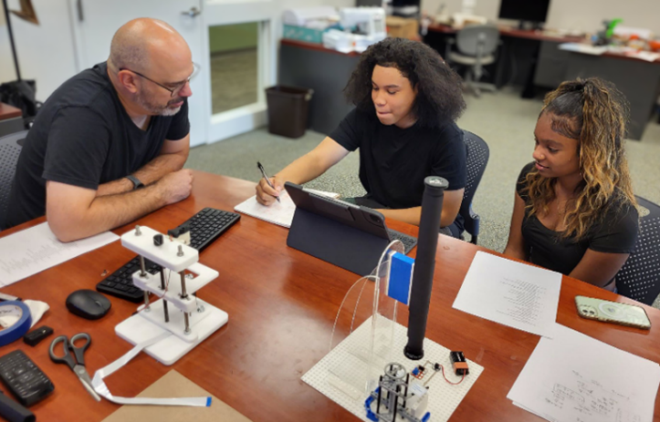
Figure 2. High school students collaborate on design of a microscope during a summer
engineering academy in the Make to Learn Laboratory at the University of Virginia.
Kelly Dooley, chief executive officer of the ITEEA, observes that in her earlier career as a practicing engineer the most satisfying projects were those undertaken for an authentic purpose, and that high school engineering students respond to a sense of purpose in much the same way.
The same pattern holds at the university level. Richard Superfine, a professor of physical science at the University of North Carolina at Chapel Hill, has taught workshops in which high school and undergraduate students use open-hardware designs to fabricate microscopes that are then used in research laboratories and experiments. He observes that students gain a deeper understanding of the principles underlying microscopy, and that seeing the instruments used by others allows students to recognize how well the microscopes perform in genuine applications – an appreciation of the value of their work that emerges when the tools reveal their power in use (R. Superfine, personal communication, 2024).

Digital Fabrication
The advent of affordable digital fabrication transformed engineering design and the prototyping process. The concept of Fabrication Laboratories (FabLabs) originated at the Massachusetts Institute of Technology. In 2001, Neil Gershenfeld established MIT’s Center for Bits and Atoms with support from the National Science Foundation to study the boundary between computation and the physical world. An accompanying course, How to Make (Almost) Anything, revealed broad demand among students to fabricate objects of their own design, and the tools assembled for that purpose – laser cutters, computer-controlled mills, 3D printers, and microcontrollers – were soon organized into a standard, replicable workshop. From these beginnings, FabLabs spread into an international network that now extends to more than 150 countries (Gershenfeld, 2005; Winn, 2023).
From the outset, the FabLab movement placed particular emphasis on developing countries, on the premise that giving a community the local means of fabrication enables it to solve its own problems rather than wait for solutions produced elsewhere. The first FabLab established outside MIT was located not in a wealthy research center but at Vigyan Ashram, a rural education center in Pabal, India, where students used digital fabrication to build practical tools for their community, including a pedal-powered generator, an egg incubator, and a weather data logger. This premise – that local fabrication capacity is itself a form of development – is the same conviction that animates the Sangala Initiative.
Digital fabrication describes the means by which the program’s work is carried out and shared. It joins three elements: affordable fabrication tools, such as 3D printers and inexpensive microcontrollers; libraries of open, reusable design files; and the instructional supports that allow teachers to put both to use. Affordable digital fabrication has made it practical for students to design, build, test, and revise scientific instruments within a classroom rather than to purchase commercial products.
This approach extends to schools a shift that has already reshaped university research. Open-source hardware – designs that can be freely accessed, replicated, modified, and shared – has allowed laboratories to replace costly commercial instruments with locally fabricated equivalents at a fraction of the price. Three benefits are commonly cited: substantial cost savings, the ability to customize a design for a particular task, and, of particular importance for education, the deeper understanding of underlying principles that comes from constructing an instrument oneself (Berry et al., 2024). The OpenFlexure microscope, an open-source instrument of sufficient quality for medical diagnosis that has been fabricated in hundreds of laboratories worldwide, illustrates how far the approach has matured (Collins et al., 2020). To date, however, the use of open hardware has occurred largely at the postsecondary level; the NTLS associations and their partners, via the Sangala Initiative, are some of the first to bring it into K–12 schools.
A key precursor to the current initiative was creation of the Educational CAD Model Library (cadlibrary.org), a peer-reviewed, open-source repository of educational design files developed through NTLS. Designs in the library are teacher-validated and tested. They can be downloaded, replicated, and modified, and improvements made by students and teachers are published back to the library as updates, where they become available to the broader community (Shapiro et al., 2025).
Digital fabrication serves the program’s central goal in two ways. Because students who design, fabricate, and document an instrument acquire the expertise to maintain and extend it, the practice builds exactly the local capacity the initiative seeks. And because the CAD library makes that work reproducible across sites, the capacity developed in one school can be shared with others rather than remaining isolated. In this way the means of the work and its purpose are aligned: the act of building becomes the mechanism through which durable, transferable expertise takes root.

The Fabricated Objects
The principles take concrete form in the objects students design and build. Two have anchored the early work: a 3D-printed microscope and a locally fabricated weather station. Each began as a response to a genuine local need, and each is intended not as a finished product delivered to schools but as something students fabricate, use, and improve.

The 3D-Printed Microscope
In the Mt. Elgon region a commercial school microscope can cost the equivalent of several years’ income. As a result, few schools in the region have microscopes, and the science instruction that depends on them is difficult to provide. The microscope was therefore a natural first object: an instrument of clear educational value whose cost places it out of reach, yet whose essential function can be reproduced through fabrication (Figure 3).
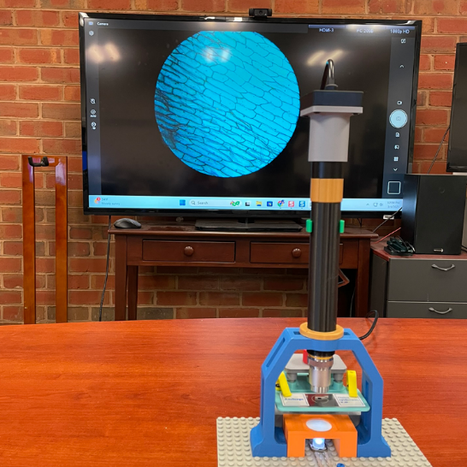
Figure 3. The NTLS Microscope: a 3D-printed, network-connected microscope.
The approach, developed as the NTLS Microscope Prototyping System, separates the optical and mechanical components of the instrument. The two compound lenses that do the optical work are purchased as inexpensive replacement parts – roughly forty dollars, or about a tenth of the cost of a four-hundred-dollar commercial school microscope – while the mechanical components, including the barrel, stage, and focus mechanism, are 3D-printed. Because the optical elements are comparable to those in a commercial instrument, the images obtained are comparable as well, approximating those of a four-hundred-dollar microscope at magnifications of forty, one hundred, and four hundred times (Shapiro et al., 2025). Figure 4 compares a stained onionskin viewed at 400x magnification with the 3D-printed microscope and with a commercial school microscope.
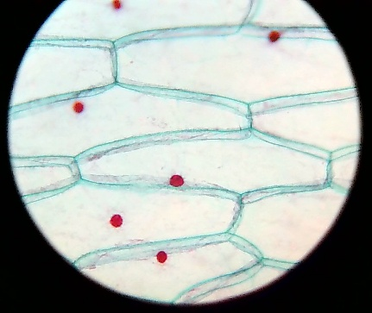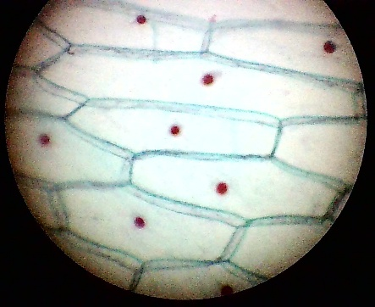
Figure 4. Images of a stained onionskin at 400x magnification captured with
the NTLS Microscope (left) and a commercial school microscope (right).
The instrument is deliberately designed as a prototyping system rather than a finished kit. A base model with a simple coarse focus is straightforward for novices to fabricate and assemble; as students gain experience, they can design and add enhancements, such as a geared fine-focus mechanism, a housing for a digital camera, or computer-controlled focus implemented in the Snap! programming language so that the underlying software remains transparent and modifiable. A networked version allows schools to share and compare images of microorganisms across different environments, and an interface to iNaturalist – an open biodiversity platform that holds more than 250 million observations (iNaturalist, 2025), the large majority contributed from North America and Europe and comparatively few from the African continent (Mason et al., 2025) – lets students contribute their own observations to a global scientific database.
Once fabricated, the microscopes are put to authentic use. They support biology instruction in schools that previously had none, and beyond the classroom they can be used to monitor local water quality or to identify plant pathogens that affect agricultural yields. Because the complete design files reside in the Educational CAD Model Library (Watts & Bull, 2025) and the software is written to be read and revised, the students who build the microscopes also acquire the means to maintain and improve them – the local capacity the initiative seeks to develop.

The Locally Fabricated Weather Station
The economy of the Mt. Elgon region is based on small-scale subsistence agriculture, yet farmers have no access to local weather data or forecasting to inform planting decisions or preparation for severe weather. With incomes already low, the loss of a single crop to an unanticipated weather event can be catastrophic. Reliable local weather information is, in effect, absent. A locally fabricated, solar-powered weather station offers a way to generate that information.
The difficulty is that the region lies off the electrical grid and the surrounding schools lack Internet access. The solution draws on low-power, long-range (LoRa) radio networking, a technology used in Rich Nguyen’s FloodWatch program to provide flood warnings in Vietnam. A LoRa transceiver can operate on less than a watt – well within the capacity of the solar power available locally – allowing weather data to be collected and transmitted without paid Internet service or cellular coverage (Figure 5).
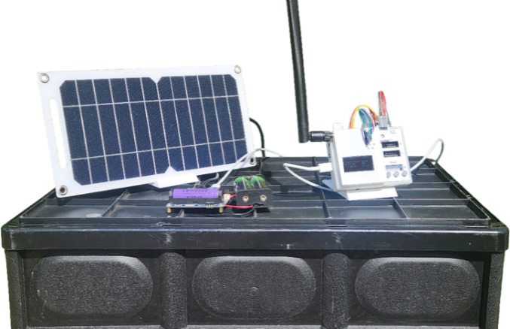
Figure 5. Prototype of a solar-powered weather station with a LoRa transceiver.
The aim is a closed loop: student-fabricated sensors gather local data, a LoRa mesh network relays it, and forecasts are returned to farmers over the same network. The weather data can also serve instruction directly, providing authentic material for lessons in geography, mathematics, science, and engineering. Because local students design and install the network, they are also better equipped to maintain it, which is essential to the system’s longevity. Problems of this kind – spanning fabrication, networking, power, and local agricultural knowledge – are unlikely to be solved by any single group working alone, and they illustrate why reciprocal innovation is treated here not as an ideal but as a practical necessity.

Jointly Developed Engineering Course
The principles and the objects converge in an introductory engineering course being developed jointly for Hawthorne-Scribner High School. The course is based on the Make to Learn Laboratory’s Design through Making curriculum, the same sequence taught to university students in EDIS 3050, so that Ugandan and U.S. students work from a shared body of activities (Make to Learn, n.d.).
The curriculum is organized as a series of foundational activities that introduce the tools of digital fabrication – two-dimensional design, image tracing and collage in Inkscape, the construction of folding papercraft, beadwork, and three-dimensional design and printing – before students undertake a more open capstone project. The activities require no prior experience, which makes the course a workable entry point in a setting where few students have previously used such tools.
Two pedagogical commitments shape the course. The first is that personal engagement precedes professional engagement. Students begin with creative, personally meaningful work – designing a collage or a papercraft scene of their own choosing – which builds confidence and fluency with the tools before the work turns to professional engineering tasks such as fabricating a microscope or a weather station. This is where the idea of sangala, or joy in making, does its work: it serves as the on-ramp to more demanding engineering. The second commitment is that professional engagement is enhanced by authentic projects, the principle discussed earlier; once students are fluent, the objects they build are ones that others will use.
The Sangala Innovation Teacher, Moses Kumenya, is collaborating with faculty and staff at the University of Virginia to complete the curriculum for the initial jointly developed course in Summer 2026. The first two Sangala Scholars, Precious Siisa and Emmanuel (Emma) Kuloba, are collaborating with Teacher Kumenya. In an initial activity, they completed the two-dimensional design activity by creating a layered papercraft scene they titled “The Bushman Hunt.” Working in Inkscape, they traced and simplified images, exported the outlines for a desktop die cutter, and assembled the cut pieces in colored cardstock to produce a three-dimensional effect; they then shared the project, with a description of their process, in the Educational CAD Model Library forum (Siisa & Kuloba, 2026). The students adapted the activity to their own setting, composing an African savanna scene rather than reproducing a supplied example (Figure 6). The same curriculum thus supports both the acquisition of technical skill and its expression in locally meaningful work – reciprocal innovation visible in a student project.
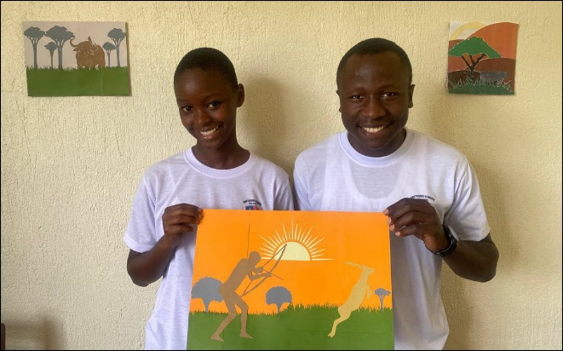
Figure 6. “The Bushman Hunt,” a layered papercraft created by Sangala Scholars
Precious Siisa and Emmanuel Kuloba in the two-dimensional design activity.
Part of the excitement of creating new tools directly within the community lies in the authentic engagement of the participants, who are eager for new solutions to the challenges their community faces. These problems, common across the Global South, were previously viewed as intractable. Our goal is to collaborate with engineering students, teachers, and members of the community to identify sustainable strategies that improve lives through access to clean water, better tools, and safer agricultural products. We hope to accomplish this goal through solutions delivered from within.
This will require a long-term capacity-building strategy. It does not take a special gene to be an engineer, or an inventor, or builder. It is not dependent on age or experience or birth status. It does require theoretical understanding of engineering principles combined with hands-on experience in the local context. This will entail development of a pipeline from middle school through technical college for the students from local villages. Locally invented and locally implemented solutions developed in collaboration with international education associations will inspire more students to pursue this path.

Pathways for Collaboration
Because the work is openly shared, it lends itself to distributed collaboration among the associations affiliated with NTLS, each contributing in its area of expertise. The ITEEA brings engineering design and fabrication; the ASTE brings the science learning the instruments are meant to support; and the SITE brings expertise in technology and teacher education. The Educational CAD Model Library provides a common place for these contributions to accumulate and be shared, since validated designs and the instructional supports that accompany them can be added, reviewed, and improved over time. Last, but not least, the REACH schools in Uganda and their students bring to the table eager and inquisitive young minds hungry for new tools and ready to fashion solutions to their seemingly impossible circumstances.
This kind of collaboration follows a pattern characteristic of NTLS, in which a conversation at the annual summit leads to subsequent collective effort. The framework that results serves as the basis for ongoing collaboration throughout the year. Additionally, these projects can grow and evolve each year at the National Technology Leadership Summit, scaling to increase their reach and impact on the field.

Conclusion
The Sangala Initiative proceeds from a single conviction: that lasting change in an under-resourced region depends less on the equipment a community receives than on the capacity it develops. A local engineering program in which students design, fabricate, use, and maintain instruments of genuine value – beginning with a microscope and a weather station – builds that capacity directly, and does so in a way that returns benefit to collaborators on both sides. Reciprocal innovation and authentic purpose guide the work, digital fabrication is the method, and local capacity to address knowledge bottlenecks is the end.
The work described here remains at an early stage, a pilot intended as a proof of concept. Its promise lies in its reproducibility: the same approach that establishes an engineering program at one high school in East Africa can, in principle, be extended to other schools and other regions of the Global South. The invitation to the associations of the NTLS, and to the readers of this journal, is to help carry it forward.

Acknowledgements

This work was supported by the University of Virginia Center for Global Innovation and Inquiry, the Jefferson Trust, and the National Science Foundation (NSF #2229627, G. Bull, P.I., 2022-24).

References
Berry, R., Early, P., Barnes, L., Dooley, K., & Bull, G. (2024). Editorial: Facilitating use of open hardware in K-12 schools — Summary of discussion at the 2024 National Technology Leadership Summit. Contemporary Issues in Technology and Teacher Education, 24(3).
Collins, J. T., Knapper, J., Stirling, J., Mduda, J., Mkindi, C., Mayagaya, V., … & Bowman, R. (2020). Robotic microscopy for everyone: The OpenFlexure microscope. Biomedical Optics Express, 11(5), 2447–2460.
Gershenfeld, N. (2005). Fab: The coming revolution on your desktop—From personal computers to personal fabrication. Basic Books
iNaturalist. (2025, June 12). We’ve reached 250 million verifiable observations [Blog post]. iNaturalist. https://www.inaturalist.org/blog/113107-we-ve-reached-250-million-verifiable-observations
Make to Learn. (n.d.). Design through making (EDIS 3050). https://maketolearn.org/studio/makerclass/
Mason, B. M., Mesaglio, T., Barratt Heitmann, J., Chandler, M., Chowdhury, S., Gorta, S. B. Z., Grattarola, F., Groom, Q., Hitchcock, C., Hoskins, L., Lowe, S. K., Marquis, M., Pernat, N., Shirey, V., Baasanmunkh, S., & Callaghan, C. T. (2025). iNaturalist accelerates biodiversity research. BioScience, 75(11), 953–965. https://doi.org/10.1093/biosci/biaf104
Shapiro, D., Watts, J., Bull, G., & Nguyen, N. R. (2025). The NTLS microscope prototyping system. Technology and Engineering Education, 2(6), 43–48.
Siisa, P., & Kuloba, E. (2026, June 19). The bushman hunt [Online forum post]. Educational CAD Model Library Forum. https://forum.cadlibrary.org/t/two-dimensional-design/89/28
Watts, J., & Bull, G. (2025). NTLS microscope [Educational object]. Educational CAD Model Library. https://doi.org/10.18130/V3/ZNR96G
Winn, Z. (2023, June 5). How MIT’s fab labs scaled around the world. MIT News. https://news.mit.edu/2023/how-mits-fab-labs-scaled-around-world-0605

About the Authors
Glen Bull is a professor in the School of Education and Human Development at the University of Virginia and founder of the National Technology Leadership Society. John Wanda is the co-founder of REACH for Uganda. Kelly Dooley is the CEO and executive director of the International Technology and Engineering Educators Association. David Slykhuis is Dean of the Dewar College of Education and Human Services at Valdosta State University and the current chair of the National Technology Leadership Society.

